# **Python Test**

For each protocol that the id is in Version1 (see the config file: protocol.json), check the frequency in the data file (MESTP.jzs) – given as fps rate.

The following table contains the corresponding appearance of entries in the log for the given duration:

|  |  |
| --- | --- |
| **Fps (frame per second)** | **Expected Frequency** |
| 36 | 164 |
| 18 | 84 |
| 9 | 48 |

Example given:

If the protocol is configured as 36 fps, it should appear 164 times in the data file.

## **Questions**

1. Which protocols are with the **wrong fps** in the config file?
2. Which IDs are in Version1 but are missing in the data file?
3. Which IDs are in the data file and missing in Version1?

## **Files:**

**Data** in: MESTP.jzs

You can find the ID of each protocol in yellow

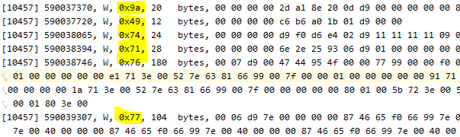

**Details of each protocol** in: protocol.json

# **Shell test**

Using the python script from the previous question, write a shell script that will take as input a folder of folders, each contains the input data file (MESTP.jzs)

The script needs to run over all the correct files and do the following:

1. Write to screen the STDOUT of the python script.
2. Create a file named "report.txt" and save on it both the STDOUT and STDERR.